Họ tên: Trần Tiến
MSSV: 22653991
Bài thực hành buổi 2

Ví dụ 2.1.
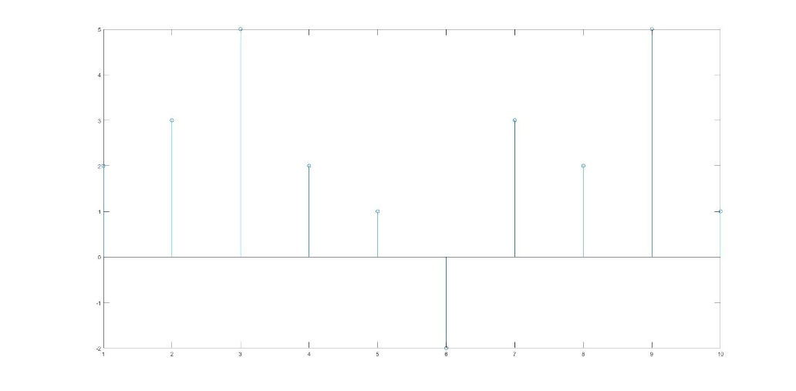
Ví dụ 2.2.
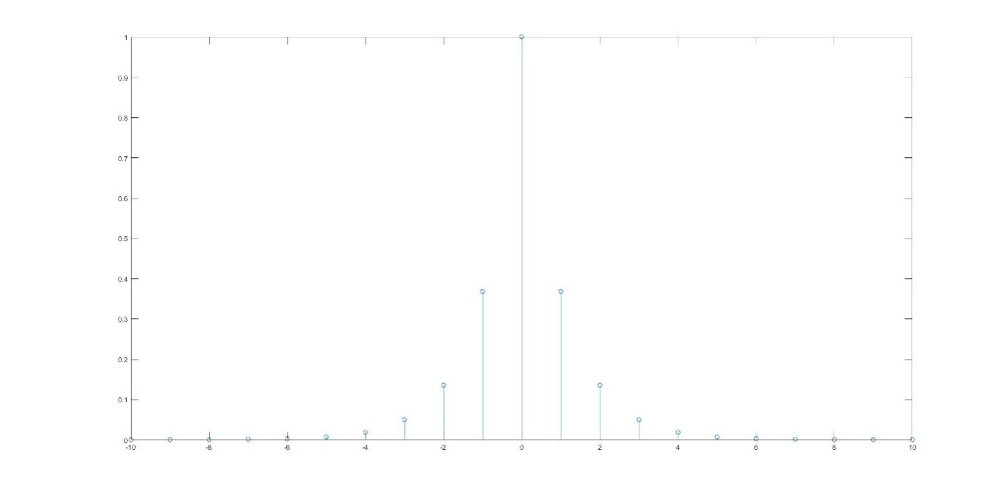
Ví dụ 2.3.
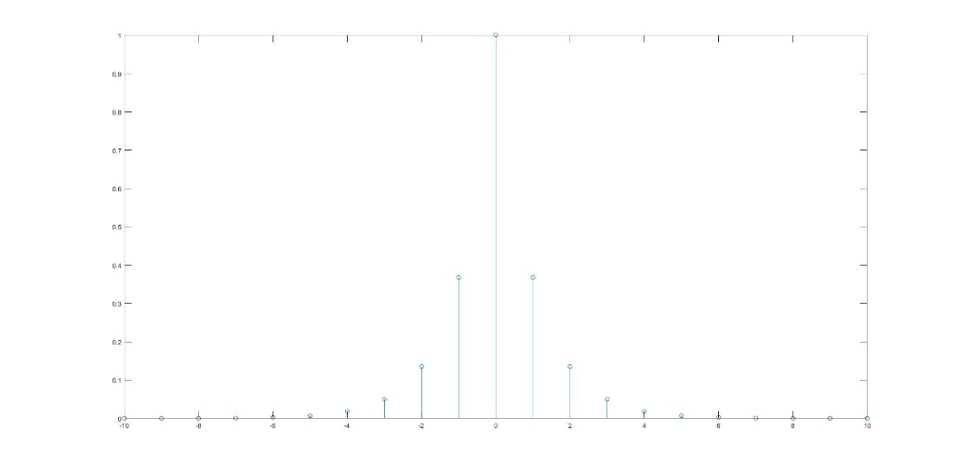

Ví dụ 2.4.
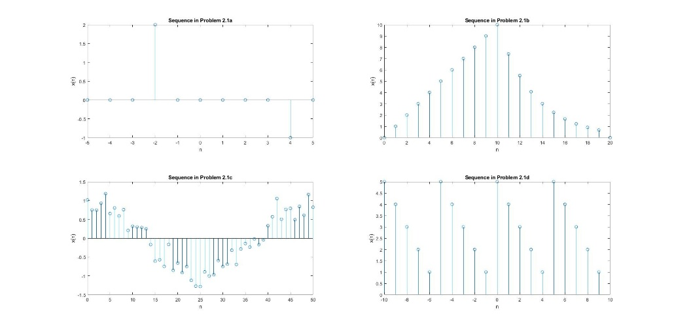
Ví dụ 2.5.
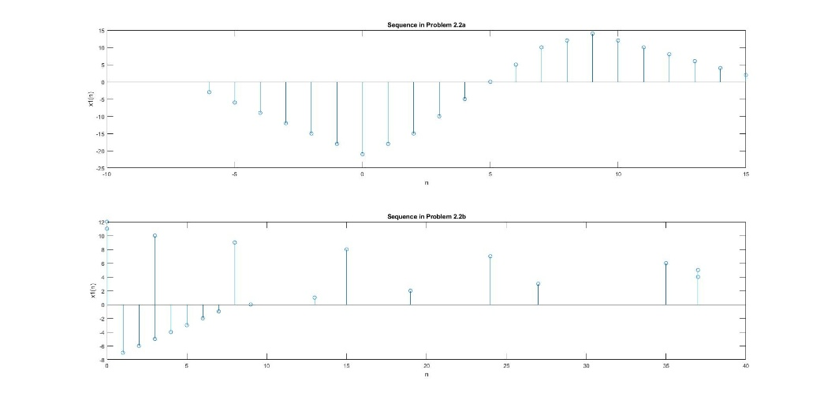
Ví dụ 2.6.
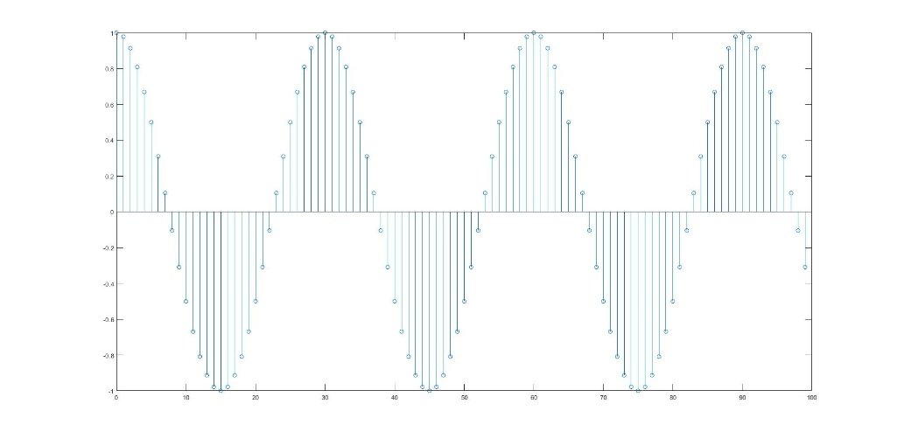

Ví dụ 2.7.
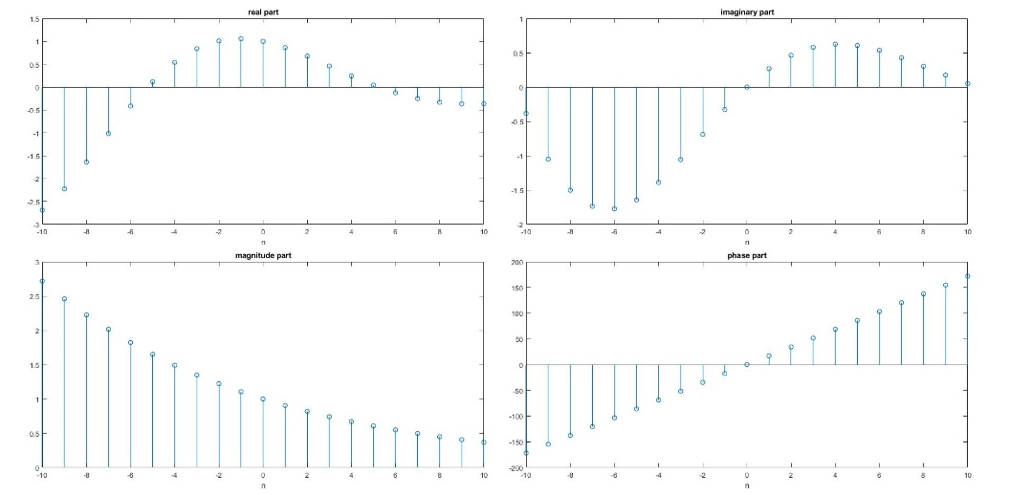
Ví dụ 2.9.
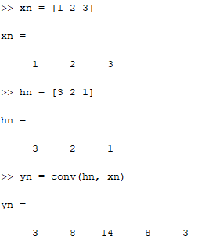
Ví dụ 2.10.
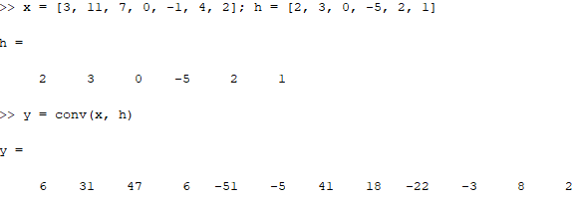
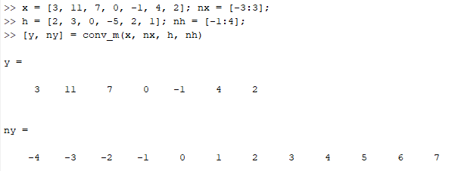
Ví dụ 2.11.
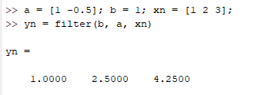
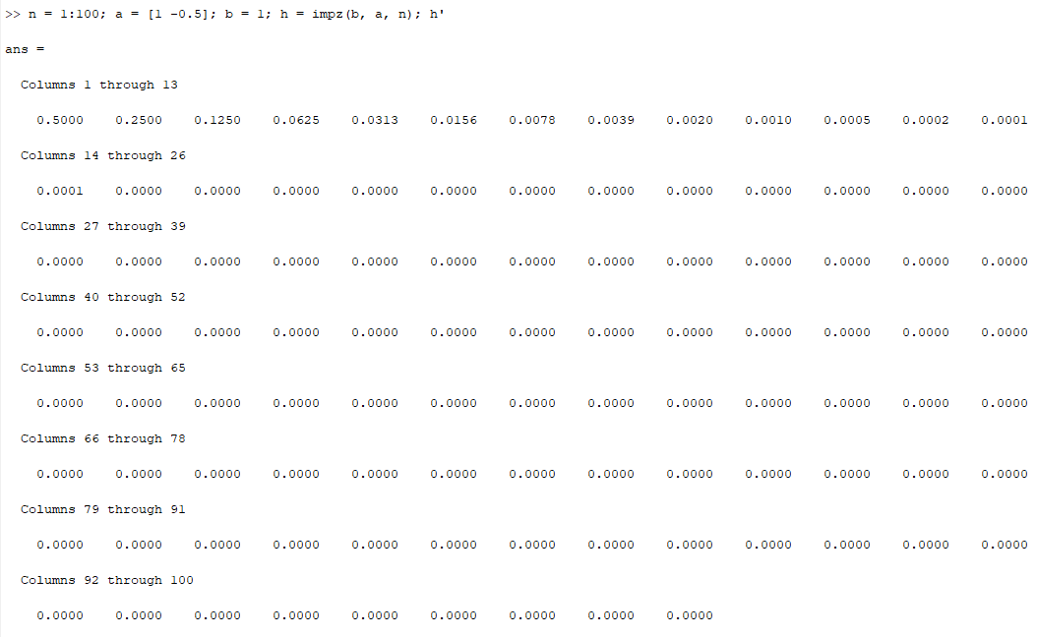

BT.2.1.
Câu a.
[x1, n1] = ham_xung(-2,-5, 15);
[x2, n2] = ham_xung(0,-5, 15);
[x3, n3] = ham_xung(3,-5, 15);
[x4, n4] = ham_xung(7,-5, 15);

[y, n] = cong_2_tin_hieu(3*x1, n1, 2*x2, n2);
[y, n] = cong_2_tin_hieu(y, n, -1*x3, n3);
[x, n] = cong_2_tin_hieu(y, n, 5*x4, n4);

stem(n, x, 'filled');
grid on;
xlabel('n');
ylabel('x1(n)');
title('Bieu dien tin hieu x1(n)');
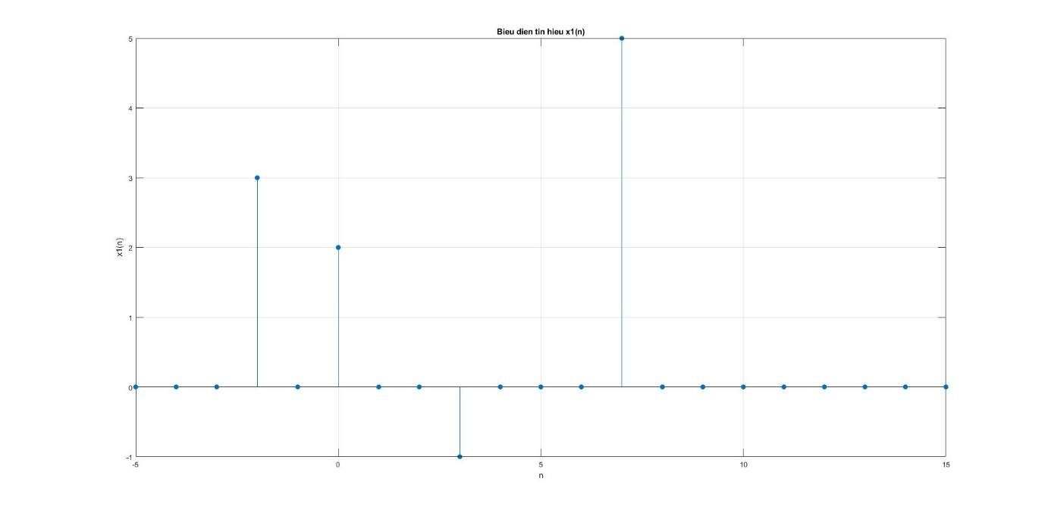

Câu b.
[x, n] = ham_xung(-2*-5, -10, 10);

for k = -5:5
[xk, nk] = ham_xung(-2*k, -10, 10);
[x, n] = cong_2_tin_hieu(x, n, exp(-abs(k))*xk, nk);
end

stem(n, x, 'filled');
grid on;
xlabel('n');
ylabel('x2(n)');
title('Bieu dien tin hieu x2(n)');
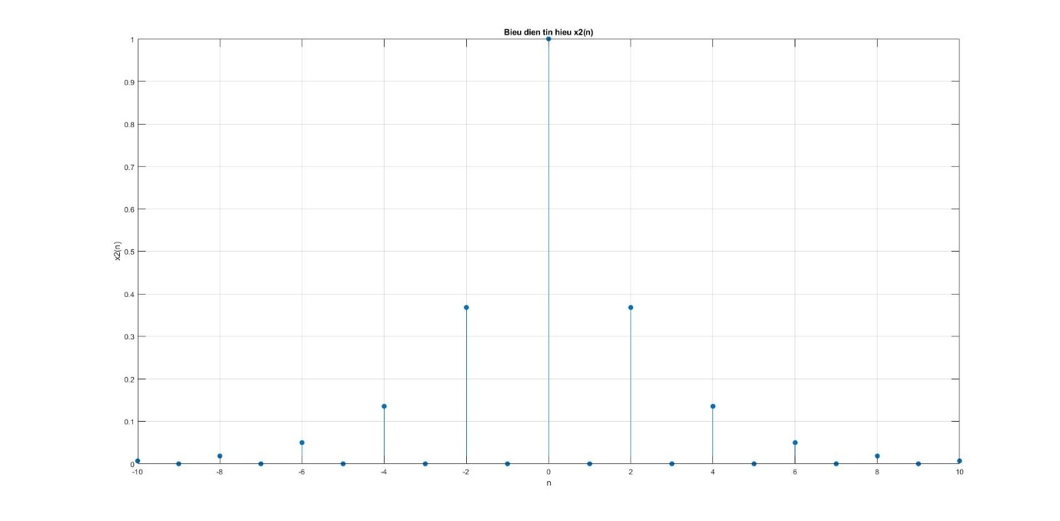

Câu c.
[x1, n1] = ham_bac(0, -5, 20);
[x2, n2] = ham_bac(5, -5, 20);
[x3, n3] = ham_bac(10, -5, 20);
[x4, n4] = ham_bac(15, -5, 20);

[y, n] = cong_2_tin_hieu(10*x1, n1, -5*x2, n2);
[y, n] = cong_2_tin_hieu(y, n, -10*x3, n3);
[x, n] = cong_2_tin_hieu(y, n, 5*x4, n4);

stem(n, x, 'filled');
grid on;
xlabel('n');
ylabel('x3(n)');
title('Bieu dien tin hieu x3(n)');
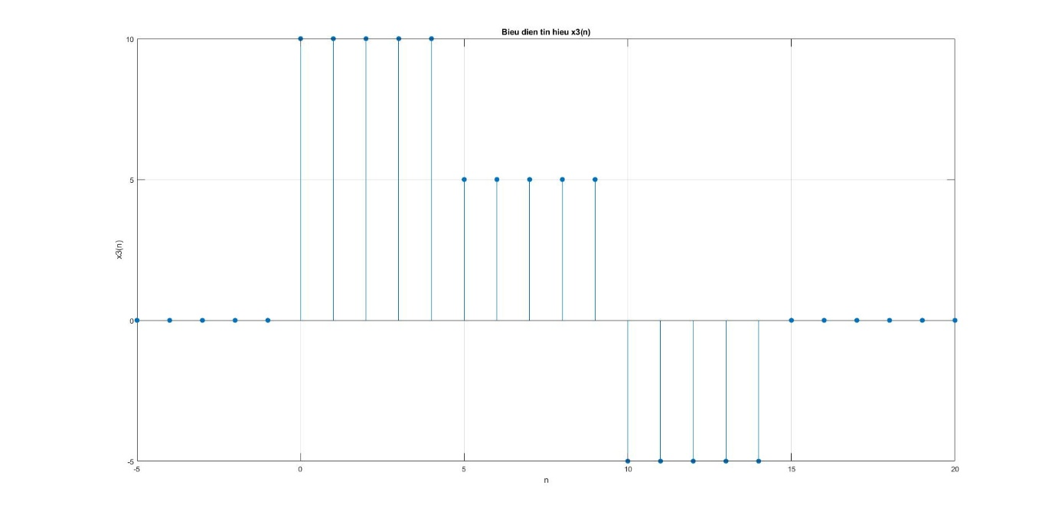

Câu d.
[x1, n1] = ham_bac(-20, -25, 15);
[x2, n2] = ham_bac(10, -25, 15);
[y, n] = cong_2_tin_hieu(x1, n1, -1*x2, n2);
x = exp(0.1*n) .* y;

stem(n, x, 'filled');
grid on;
xlabel('n');
ylabel('x4(n)');
title('Bieu dien tin hieu x4(n)');
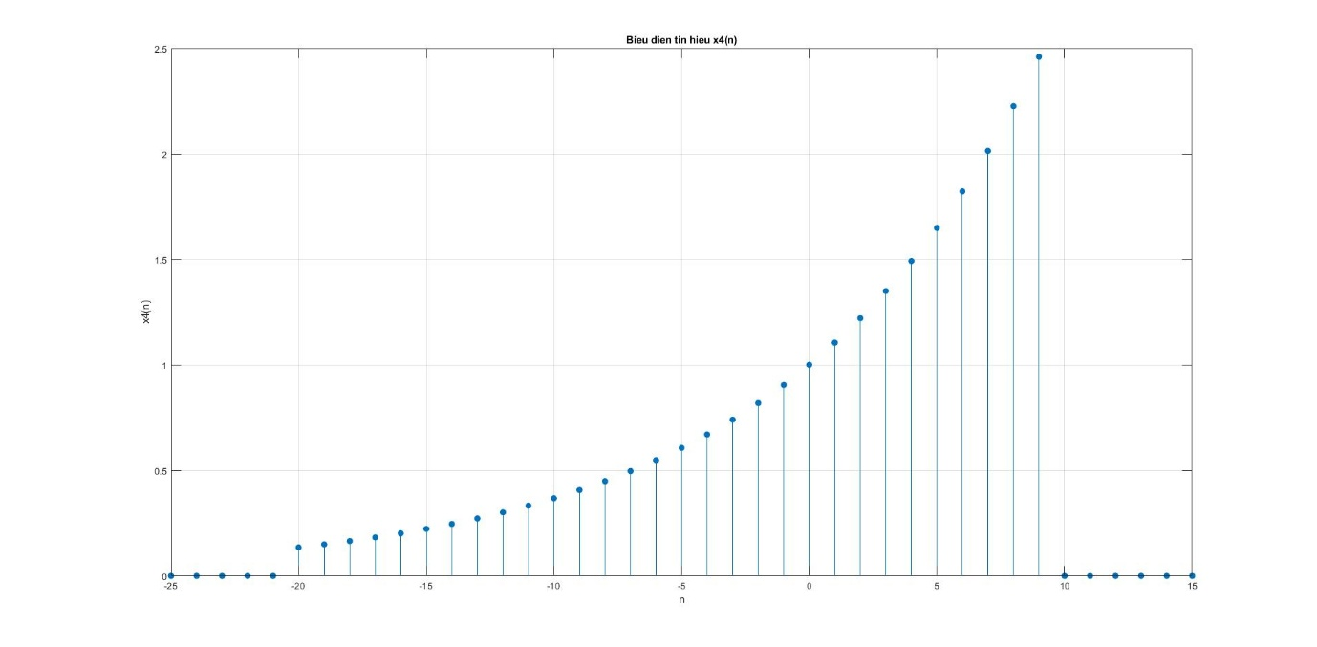

Câu e.
n = -200:200;

[y, n] = cong_2_tin_hieu(5*cos(0.49*pi*n), n, 5*cos(0.51*pi*n), n);

stem(n, y, 'filled');
grid on;
xlabel('n');
ylabel('x5(n)');
title('Bieu dien tin hieu x5(n)');
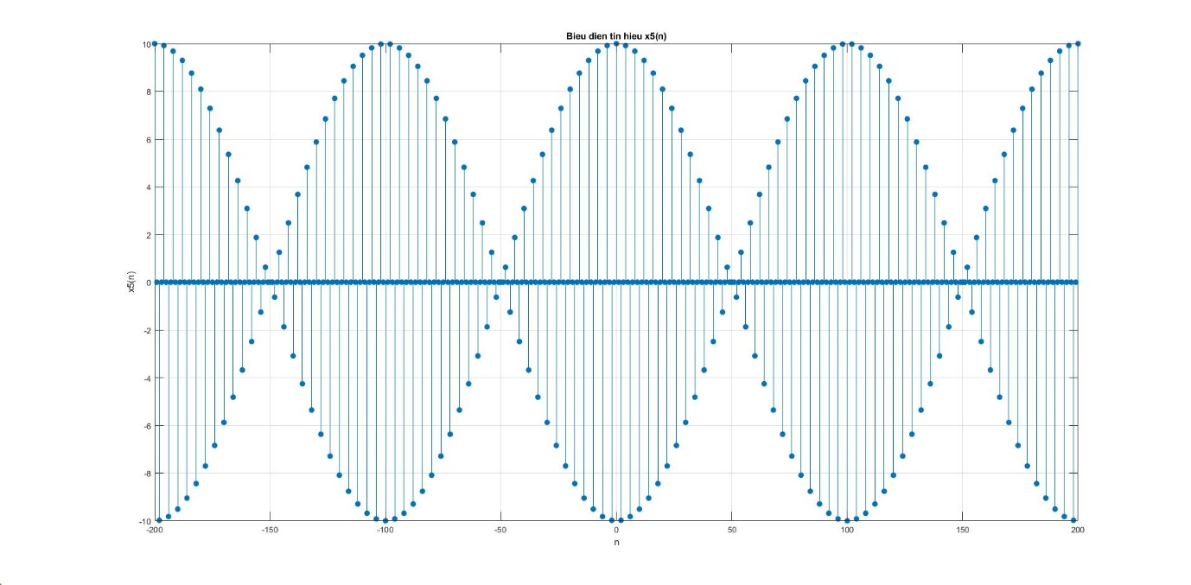

Câu f.
n = -200:200;

[y, n] = nhan_2_tin_hieu(2*sin(0.01*pi*n), n, cos(0.5*pi*n), n);

stem(n, y, 'filled');
grid on;
xlabel('n');
ylabel('x6(n)');
title('Bieu dien tin hieu x6(n)');
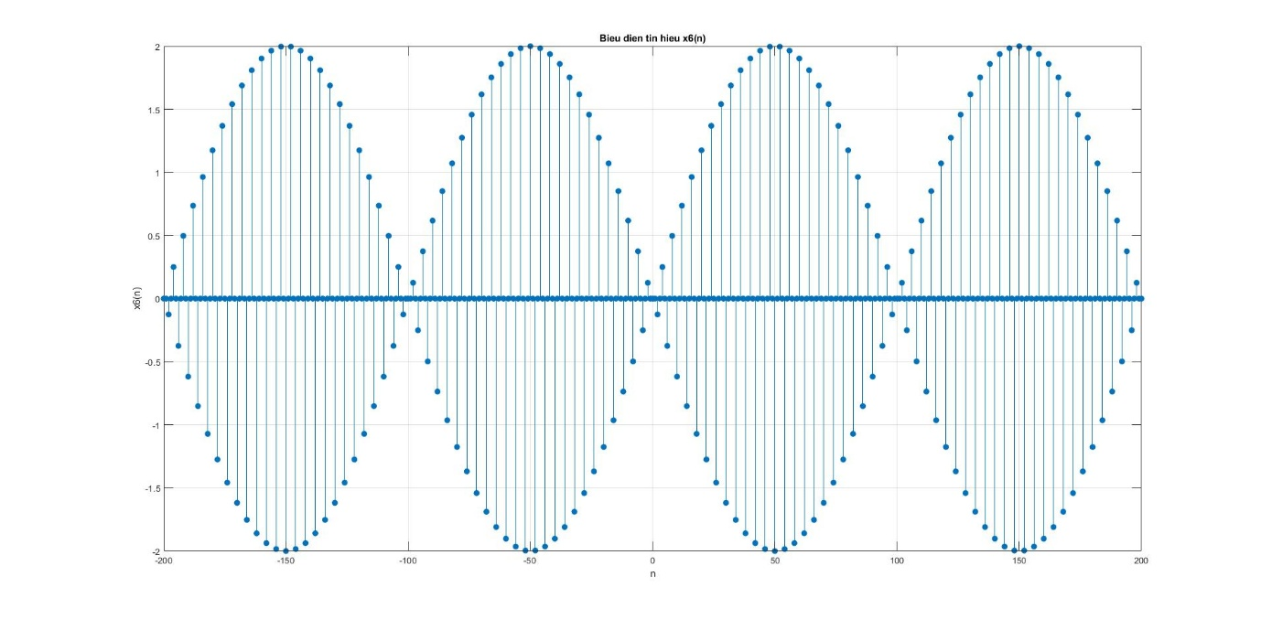

Câu g.
n = -100:100;

[y, n] = nhan_2_tin_hieu(exp(-0.05*n), n, sin(0.1*pi*n + pi/3), n);

stem(n, y, 'filled');
grid on;
xlabel('n');
ylabel('x7(n)');
title('Bieu dien tin hieu x7(n)');
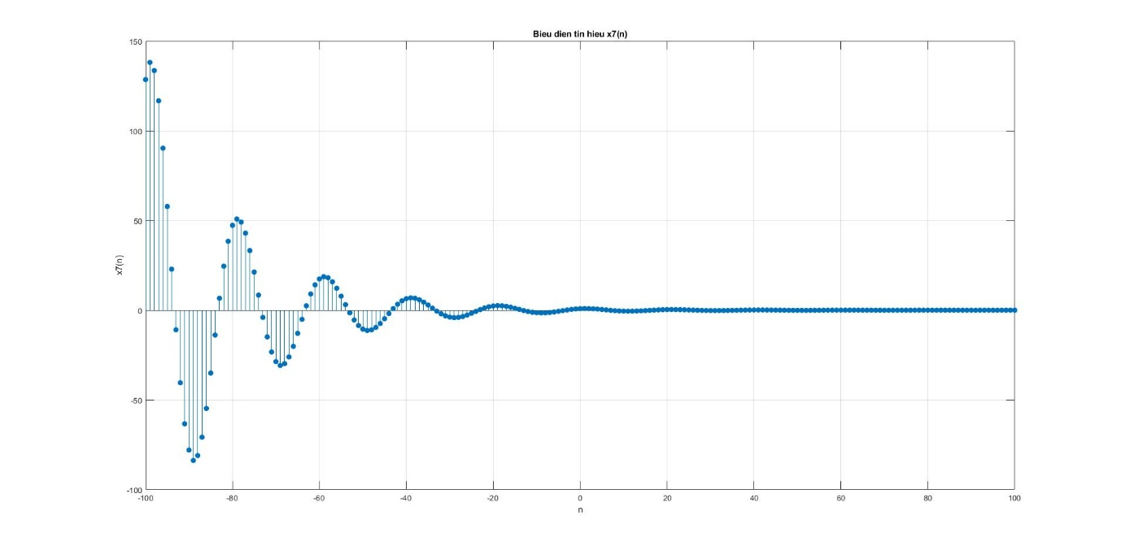

Câu h.
n = 0:100;

[y, n] = nhan_2_tin_hieu(exp(-0.05*n), n, sin(0.1*pi*n), n);

stem(n, y, 'filled');
grid on;
xlabel('n');
ylabel('x8(n)');
title('Bieu dien tin hieu x8(n)');
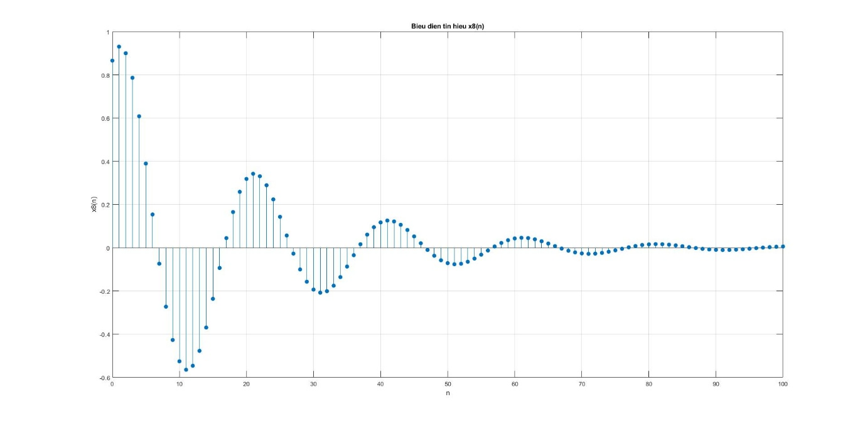

Câu i.
n = 0:100;

[y, n] = nhan_2_tin_hieu(exp(0.01*n), n, sin(0.1*pi*n), n);

stem(n, y, 'filled');
grid on;
xlabel('n');
ylabel('x9(n)');
title('Bieu dien tin hieu x9(n)');
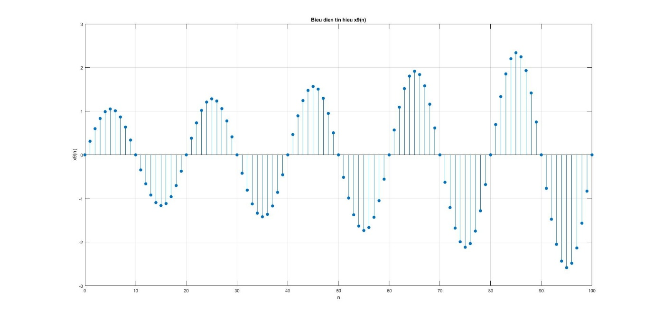

BT.2.2.
Câu a.
n = -10:14;
x = [-2, -1, 0, 1, 2];
xtilde = x' * ones(1, 5); xtilde = xtilde(:)';

stem(n, xtilde, 'filled');
grid on;
xlabel('n');
ylabel('x(n)');
title('Bieu dien tin hieu x(n)');
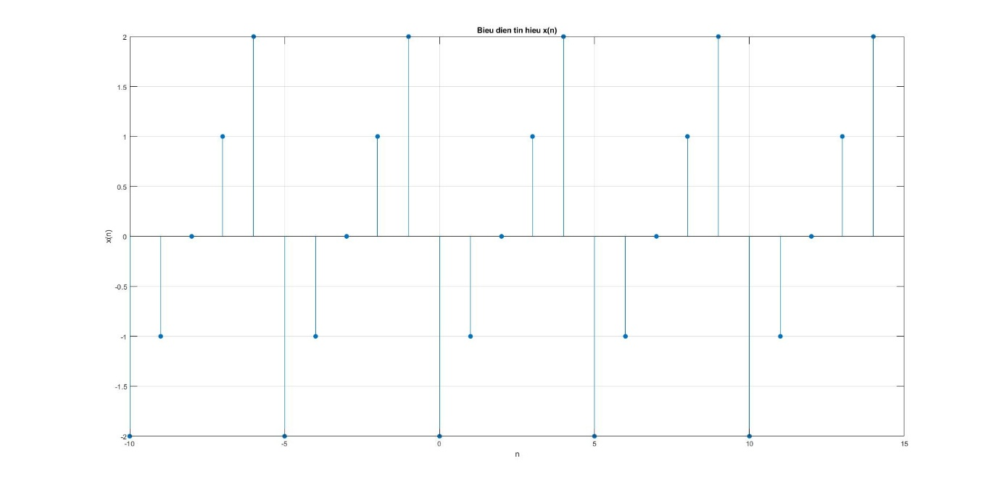

Câu b.
[x1, n1] = ham_bac(0, -2, 2);
[x2, n2] = ham_bac(20, -2, 2);
[y, n] = cong_2_tin_hieu(x1, n1, -x2, n2);
[y, n] = nhan_2_tin_hieu(exp(0.1*n), n, y, n);

xtilde = y' * ones(1, 4); xtilde = xtilde(:)';
ntilde = n(1) + (0:(length(xtilde)-1));

stem(ntilde, xtilde, 'filled');
grid on;
xlabel('n');
ylabel('x2(n)');
title('Bieu dien tin hieu x2(n)');
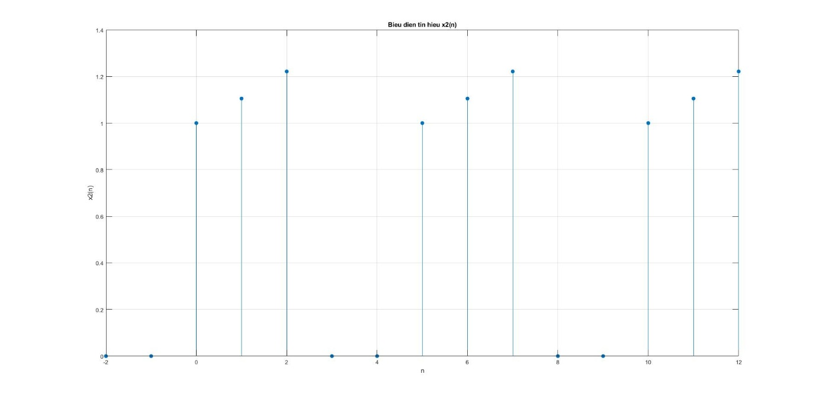

Câu c.
[x1, n1] = ham_xung(0, -2, 2);
[x2, n2] = ham_xung(10, -2, 2);
[y, n] = cong_2_tin_hieu(x1, n1, -x2, n2);
[y, n] = nhan_2_tin_hieu(sin(0.1*pi*n), n, y, n);

xtilde = y' * ones(1, 4); xtilde = xtilde(:)';
ntilde = n(1) + (0:(length(xtilde)-1));

stem(ntilde, xtilde, 'filled');
grid on;
xlabel('n');
ylabel('x3(n)');
title('Bieu dien tin hieu x3(n)');
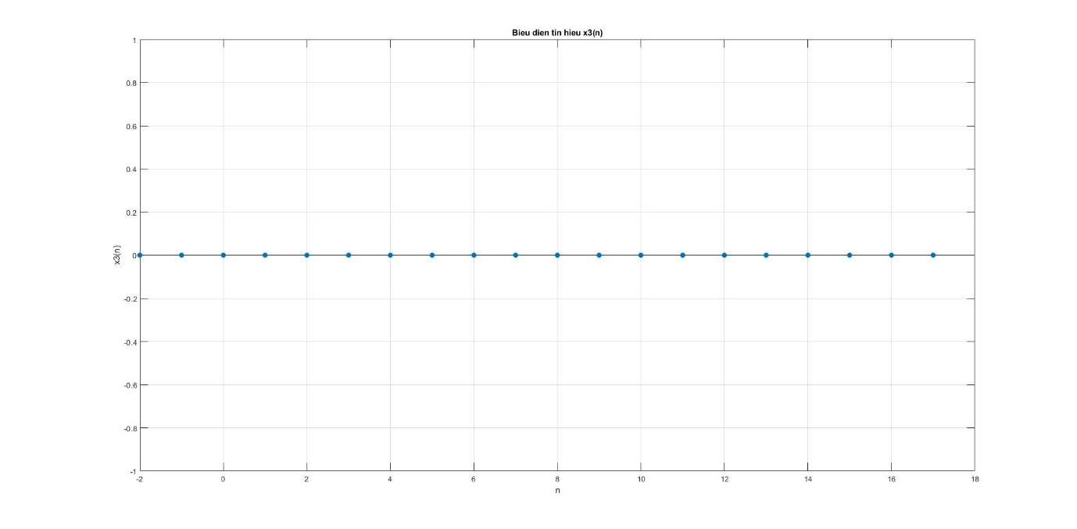

Câu d.
n = 0:24;
x1 = [1, 2, 3];
x2 = [1, 2, 3, 4];

xtilde1 = x1' * ones(1, 9); xtilde1 = xtilde1(:)'; xtilde1 = xtilde1(1:25);
xtilde2 = x2' * ones(1, 7); xtilde2 = xtilde2(:)'; xtilde2 = xtilde2(1:25);

[y, n] = cong_2_tin_hieu(xtilde1, n, xtilde2, n);

stem(n, y, 'filled');
grid on;
xlabel('n');
ylabel('x4(n)');
title('Bieu dien tin hieu x4(n)');
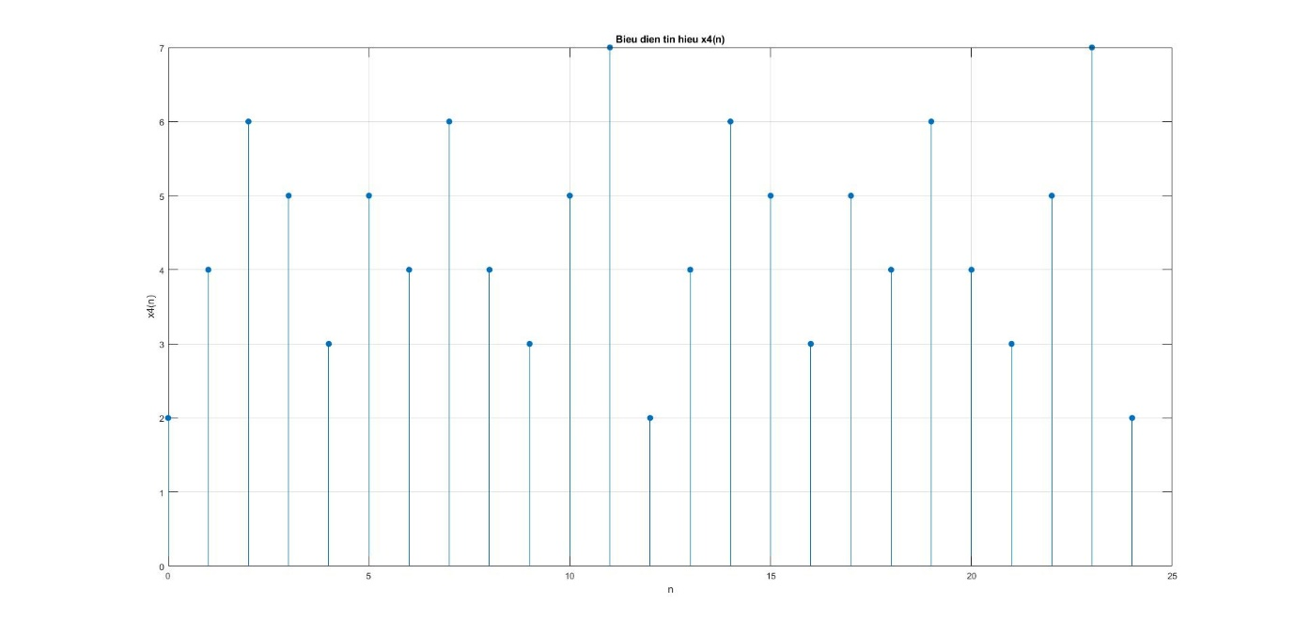
Lập lại 2 lần

BT.2.3.
n1 = 0:20;
x = (0.9).^n1;

n2 = -20:0;
y = (0.8).^(-n2);

z = conv(x, y);
n = (n1(1) + n2(1)) : (n1(end) + n2(end));

stem(n, z, 'filled');
grid on;
xlabel('n');
ylabel('z(n)');
title('Bieu dien tin hieu z(n)');
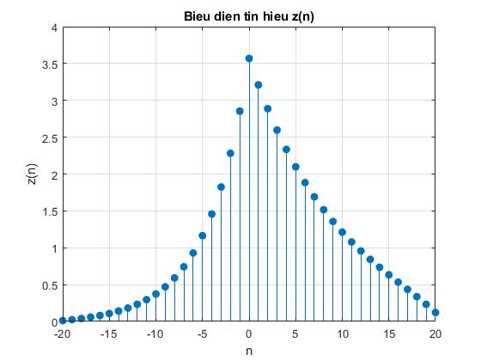
BT.2.4.

BT.2.5.

BT.2.6.
Câu a.
[x1, n1] = ham_bac(0, -5, 25);
[x2, n2] = ham_bac(20, -5, 25);
[y, n] = cong_2_tin_hieu(5*x1, n1, -5*x2, n2);

[x, n] = cong_2_tin_hieu(y, n, -1*dich_chuyen_tin_hieu(y, n, 1), n);

stem(n, x, 'filled');
grid on;
xlabel('n');
ylabel('x6a(n)');
title('Bieu dien tin hieu x6a(n)');
